**CHAPTER 1**

**THE STUDY AND ITS PROBLEMS**

**A. BACKGROUND OF THE STUDY**

To recognize an individual, we often use facial features as our references and, over the past few decades, using the same method, similar recognition techniques have been able to recognize automatically an individual. Simple geometric models were used by the early face recognition algorithms, but the recognition process has now matured into a science of sophisticated mathematical representations and matching processes. Face recognition can be used for both verification and identification.

The study of biometrics in the last three decades has greatly improved and the application of this concept has been widely used in different ways particularly for security and important social purposes. Therefore, identification and validation procedures have developed into main technology in numerous areas, such as entrance control and access control.

One form of biometric solutions is what we called face recognition. Face recognition is an integral part of biometrics. In biometrics basic traitsof human is matched to the existing data and depending on result of matchingidentiﬁcation of a human being is traced. Facial features are extracted andimplemented through algorithms which are eﬃcient and some modiﬁcations aredone to improve the existing algorithm models.Computers that detect and recognize faces could be applied to a wide variety ofpractical applications including criminal identiﬁcation, security systems, identityveriﬁcation etc. Face detection and recognition is used in many places nowadays,in websites hosting images and social networking sites. Face recognition anddetection can be achieved using technologies, methodologies and algorithmsthat are related to computer science.

Within last several years, there are several face recognition algorithms written by researchers. One of which is the Eigenface algorithm.The main idea of *Eigenface* is to get the features in mathematical sense as an alternative to physical face feature by using mathematical transform for recognition. There are two phases for face recognition using *Eigenface*. The first phase is the training phase. In this phase, a large group of individual faces is acted as the training set. These training images should be a good representation of all the faces that one might encounter. The size, orientation and light intensity should be standardized. For example, all images are of size 125 x 125 pixels and all are frontal faces. Each of the images in the training set is represented by a vector of size N by N, with N representing the size of the image. With the training images, a set of eigen-vectors is found by using Principal Component Analysis (PCA). The basic idea of PCA is to take advantages of the redundancy existing in the training set for representing the set in a more compact way.

But to maintain an efficient and well-trained facial recognition system, a finite computer algorithm cannot stand unaided. As human brain has the learning ability to recognize the persons by their faces even the feature characteristics change with time because the neurons of human brain are trained by reading or learning the face of a person and can identify that face even after several years. Similarly, this ability of training and identifying is converted into machine learning system using Artificial Neural Networks (ANN). In machine learning and cognitive science,artificial neural networks (ANNs) are a family of models inspired bybiological neural networks (thecentral nervous systemsof animals, in particular the brain) which are used to estimate or approximate functions that can depend on a large number of inputs and are generally unknown.The basic function for the face recognition system is to compare the face of a person which is to be recognized with the faces already trained in the Artificial Neural Networks and it recognized the best matching face as output even at different lightening conditions, viewing conditions and facial expressions.

**B. EXISTING ALGORITHM**

**Principal Component Analysis based Eigenface Algorithm**

Algorithm features of the face image are extracted using Principal Component Analysis (PCA). PCA is dimensionality reduction method which retain majority of the variations present in the data set. PCA is a way of identifying patterns in data and expressing the data in such a way as to highlight their similarities and differences. Eigenface is the simplest approach to PCA. Eigenface is a face recognition algorithm that gets the facial features in mathematical sense as an alternative to physical face feature by using mathematical transform for recognition as shown in Figure 1.

Read the colored image and convert it into gray scale image

Compute the eigenvectors of covariance matrix

Compute the projected image

Calculate the eigenvalues of the covariance matrix and keep only k largest eigenvalues

Get the image data in form of a matrix

Calculate covariance matrix

Normalize each input face image by subtracting the mean face

Calculate the mean

Compute eigenfaces containing highest information of face images

*Figure 1: Basic Architecture of Eigenface using PCA*

**Artificial Neural Networks**

The multi-layered Artificial Neural Networks (ANN) has different layers of processing elements. One of the basic structure of an ANN has three major layers namely, Input Layer, Hidden Layer and Output Layer respectively as shown in Figure 2.

Output Yi

Xi1

X31

X21

X11

Output layer

Hidden layer

Input layer

INPUT – Xi1  
WEIGHT – WijOUTPUT – Yi  
SUM = Wij Xi  
Y = F(SUM) where  
F = transfer function

Wij

*Figure 2: Basic Architecture of multi-layered ANN*

In face recognition system using ANN, the model works in the following frames:

***Input to Feed Forward Network:***

First, the parameters are selected for required Neural Networks operation i.e. the number of input layers, hidden layers and output layers. These input neurons receive the inputs signal from the training data of face images. Each input has its own weights.

***Back Propagation and Weight Adjustment:***

The input layer processes the data to the hidden layer which computesthe data further and passes it to the output layer. Output layer compare it with the target value and obtain the error signals. These errors are sent back for adjusting the weights of each layer to minimize the error as shown in Figure 3.

Target

Compare

Neural Network including connections (called weights) between neurons

Output

Input

Adjust  
Weights

*Figure 3: Process flow of Back Propagation and Weight Adjustment of ANN*

***Mathematical Function:***

It performs the mathematical operation on the output signal. The functions can be threshold function, log-sigmoid and Tangent hyperbolic function. If the output values of the function are similar to the output values of the Tested face, the face is detected. Hence, the Neural Networks provides the response to the input which is similar to the training data.

**Emgu CV Cross Platform .NET Wrapper**

Emgu CV is a cross platform .Net wrapper to the OpenCV image processing library. Allowing OpenCV functions to be called from .NET compatible languages such as C#, VB, VC++, IronPython etc. The wrapper can be compiled by Visual Studio, Xamarin Studio and Unity, it can run on Windows, Linux, Mac OS X, iOS, Android and Windows Phone.

**C. STATEMENT OF PROBLEMS**

**1.) *Eigenface algorithm using Principal Components Analysis*is is time consuming in providing numerous inputs for face detection.**

The only input accepted by the Eigenface algorithm using PCA is a single N by N image. The single image accepted by the system will be used forface recognition. Every time the system will be used for face recognition, the user must provide his/her image to be able to proceed to the recognition stage. Same process applies for each individual every time they use the face recognition system.

*Sample Result:*

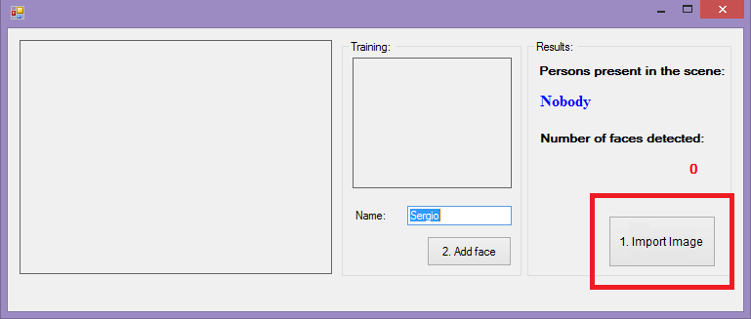

**2.) Unregistered person can be recognized by the *Eigenface algorithm*.**

The input face image is extracted by creating the feature vectors of maximum varied face points and computing Covariance column matrix using PCA. These faces are projected onto the face space that spans the significant variations in the face images stored in the database. These feature vectors are the eigenvectors of covariance matrix and having the face like appearance so that we call them eigenfaces. The eigenfaces where then computed and the one with the highest information of face images is the matched image.

The problem to this approach occurs when someone with one or more facial feature is likely similar to other registered images and the eigenface value of the recorded image is near to one of the eigenfaces stored in the database even if they are not the same person then it produces a result that states that the input is recognized as a registered face with the identity of the registered user.

*Sample Result:*

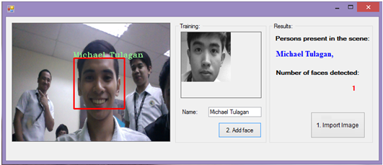

**3.) The *Eigenface algorithm* is completely vulnerable to image and video spoof attacks.**

Recognition algorithms can be divided into two main approaches, geometric, which looks at distinguishing features, or photometric, which is a statistical approach that converts an image into values and comparing the values with templates to eliminate variances.Principal Component Analysis with Eigenface algorithm is one of the photometric recognition algorithm approach.

Regardless of the source where the face was detected the algorithm will still proceed to the recognition stage which can lead to a recognized image even if the source of the image is not of a live person.

*Sample Result:*

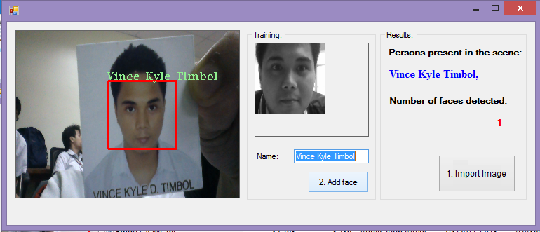

**E. OBJECTIVES OF THE STUDY**

The objective of this research is to formulate a way to develop a Face Recognition Algorithm using Artificial Intelligent Methodology that is capable of learning and recognizing an individual faster, that is closer to how humans recognize faces. We also seek to develop a more secure and enhanced efficiencyaided by systems that can verify and validate someone’s identity in a real time process.

**F. IMPORTANCE OF THE STUDY**

The face is an important part of who you are and how people identify you. It is arguably one of a person's most unique physical characteristics. While humans have the innate ability to recognize and distinguish different faces for millions of years, computers are just now catching up. Using traditional computer algorithms for face recognition is not enough to be considered near to natural face perception. But using the most advance technique in our technology today can possibly achieve a more efficient face recognition.

As Artificial Intelligence became the future of computing, further development of technologies in this area will surely be the trend for the future. Implementation of this concept to face recognition algorithm is an effective technique and cost-efficient in terms to the security of biometric systems such as face recognition systems.

1. Face recognition requires no physical interaction on behalf of the user and it can lead to a faster biometric system.
2. Face recognition unlike other biometric systems is very affordable and continues to be a lot cheaper.
3. Intelligent face recognition system can eliminate or greatly reduce errors on identifying a person. Artificial Neural Network (ANN) as a machine learning concept has the ability to effectively recognize a person as time passes by. It has the capability to learn on its own without explicitly programming the system.
4. Artificial intelligence can be applied in carrying out repetitive and time consuming tasks efficiently.
5. Implementing Artificial Neural Networks in face recognition is a great advantage when it comes to processingnumerous stored images.
6. The greatest advantage of artificial intelligence is that it can continuously perform the same task without getting bored or tired. When employed to carry out dangerous tasks, the risk to human health and safety is reduced.

**G. SIGNIFICANCE OF THE STUDY**

This study seeks to benefit the following groups of people:

1. To the ***programmers and developers,*** this study will encourage them to partake in the improvement of Face Recognition Algorithms using Artificial Intelligence and to advance and develop applications and system that uses this approach.
2. To ***business owners and organizations,*** A.I. is the current trend of today’s technology and is also a powerful and innovative way to strengthen security.This study can help them to take their business to the next level.
3. To ***students***, that they will be more interested in learning Artificial Intelligence as a subject of importance, enjoyment and knowledge. It can also educate and encourage them to explore other ways to implement Artificial Intelligence.
4. Lastly, to the ***future researchers,*** that they will further enhance this study through investing more time in finding out the effectiveness and relevance and to what extent can A.I. help in today’s computing technologies. Also, to research for the latest and effective security methods and protocols that can be applied to the algorithm.

**H. SCOPE AND LIMITATIONS**

This study focuses on the Enhancement of Principal Component Analysis  
Based Face Recognition Using Eigenface Algorithm with Implementation of Artificial Neural Network Applied in An Application for Tracing Missing People. Software, APIs and SDKs that will be used in the development of this project are either open-source or licensed technologies. Additionally, functions and features of this project only covers topic of Face Detection, Face Recognition, and Machine Learning, not topics related to Medicine, Engineering and other subject areas not mentioned or related above. The Software for this enhancement will only be an executable forms-based application, not a mobile application.

This study does not cover proprietary technologies and features of similar Face Recognition Systems and Face Recognition Software such as iPhoto (Apple), DeepFace (Facebook), Picasa (Google) etc. Any similarity among these systems within this study is not intended and may be incidental unless it’s open-source and available publicly.

**I. DEFINITION OF TERMS**

**Artificial Neural Networks (A.N.N.s).**A family of models inspired bybiological neural networks (thecentral nervous systemsof animals, in particular the brain) which are used to estimate or approximate functions that can depend on a large number of inputs and are generally unknown.

**Back Propagation.**Algorithm used for training.

**Biometrics.**The measurement and analysis of unique physical characteristics especially as a means of verifying personal identity.

**Eigenface Algorithm.**A face recognition algorithm that gets the facial features in mathematical sense as an alternative to physical face feature by using mathematical transform for recognition.

**Eigenvalues.**A root of the characteristic equation of a matrix.

**Eigenvectors.**A nonzero vector that is mapped by a given linear transformation of a vector space onto a vector that is the product of a scalar multiplied by the original vector.

**EmguCV.**A cross platform .Net wrapper to the OpenCV image processing library.

**Face Recognition.**An integral part of biometrics wherein facial features is examined and verified to match an existing person.

**Neurons.** Nodes of an ANN.

**Principal Component Analysis (P.C.A.).**A way of identifying patterns in data and expressing the data in such a way as to highlight their similarities and differences.

**Training.**The process of determining the value of weight and bias.

**Training Set.**Database of faces within the system.